Name:______________________________________ Date: ____________ Period: ____
Chapter 1 Closure Problems 1-142 to 1-150
1-142. Vanson has a bunch of boxes that are all the same. He stacked four boxes, measured the stack, and found that it was three feet high.
  - How high will a stack of 20 of these boxes be?

  - The ceiling in the room where Vanson is working is just a little more than 9 feet high. He wants to stack boxes from the floor to the ceiling. How many boxes will fit in one stack?

1-143. Find the perimeter and area of Jacob’s swimming pool shown in the diagram below. Be sure to show all of your work.
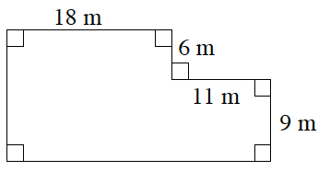

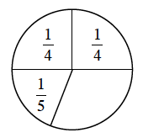
1-144. Tuan is playing a game, but the spinner is incomplete. If the numbers in the sections of the spinner represent the probabilities of spinning each section, help him figure out the fraction for the missing section of the spinner.

1-145. Complete each portions web.
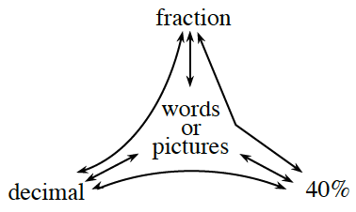
a.

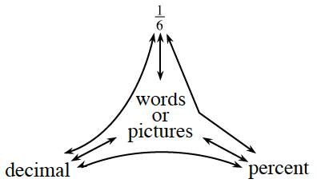
b.

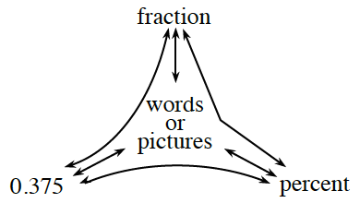
c.

1-146. Add 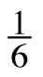 + 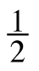. Show all of your steps.

1-147. Write “theoretical” or “experimental” to describe the following situations.
- The chance of rolling a sum of three with two number cubes is 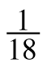.

- I drew five cards out of a deck and got clubs three times.

- I bought six raffle tickets and did not win anything.

- Based on a mathematical model, the chance of a flood next year is 1.2%

1-148. The county-fair prize wheel has equally spaced sections with the following colors: one is golden, two are silver, three are green, four are blue, six are red, and nine are yellow.
- What is the probability of landing on gold? Give your answer as a fraction and as a percent.

- If the probability of landing on yellow is 36%, what is the probability of not landing on yellow?

- If the wheel is spun 100 times, how many times would you expect to land on silver?

1-149. Kimberly is playing “Guess My Number.” Her clue is, “When I triple my number and subtract 7, I get 83.” Find Kimberly’s number and explain how you know your answer is correct.

1-150. For each of the problems above, do the following:
Draw a bar or number line that represents 0 to 10.
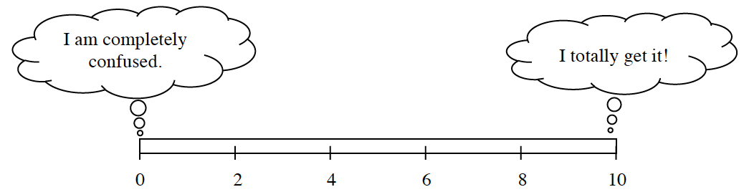
Color or shade in a portion of the bar that represents your level of understanding and comfort with completing that problem on your own.
If any of your bars are less than a 5, choose one of those problems and complete one of the following tasks:
  - Write two questions that you would like to ask about that problem.
  - Brainstorm two things that you DO know about that type of problem.

If all of your bars are a 5 or above, choose one of those problems and do one of these tasks:
  - Write two questions you might ask or hints you might give to a student who was stuck on the problem.
  - Make a new problem that is similar and more challenging than that problem and solve it.

